OUR SERVICES>INTERIOR DESIGN SERVICES
EXTENSIVE SOLUTION FOR INTERIOR DESIGNS
- Introduction
DIGITAL NEST SOLUTIONS is the Leading Interior Design provider in India
We produce excellent grade interior design services with a team of more than 30 skilled and specialized interior designers, working around the clock to meet the needs of clients from all over the world.
- Conceptual design
Gathering the statistics, Understanding the design requirements and produce unique design with 2D and 3D view along with updating the corrections suggested by customer
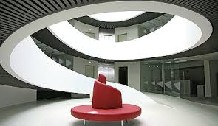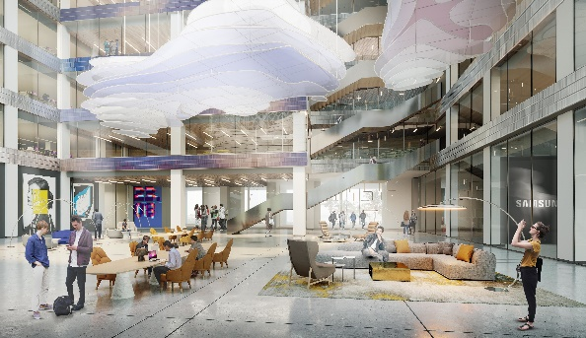

- 3D Design
Creative three-dimensional design by utilizing the contemporary technology tools by keeping requirement and cost of the customer with the best quality of material selection
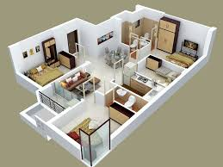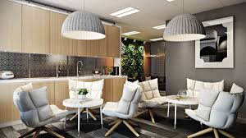

- 2D Design
A 2D Space plan provides flat layout of space from above without perspective or depth.
show the walls and room layout, plus fixed installations like windows, doors, and stairs as well as basic furniture placement
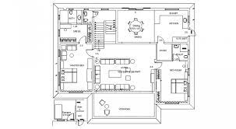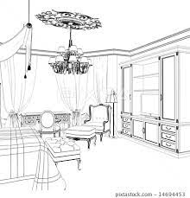

a. Residential Design
Our expert designers will design residential space in a way that is bound to leave a lasting impression on the minds of others. Which includes latest,
i. Living room – Contemporary designs with minimum utilization of space
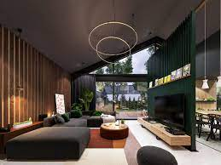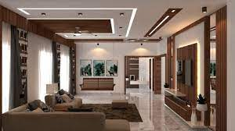
ii. Modular Kitchen – Creative design with high quality materials and finish
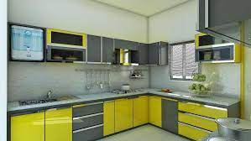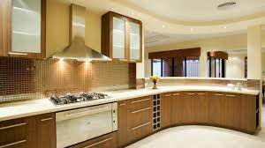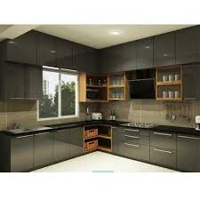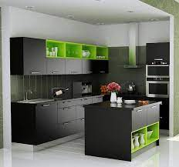
iii. Bedroom – Versatile design providing best comfort
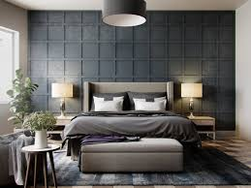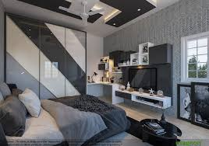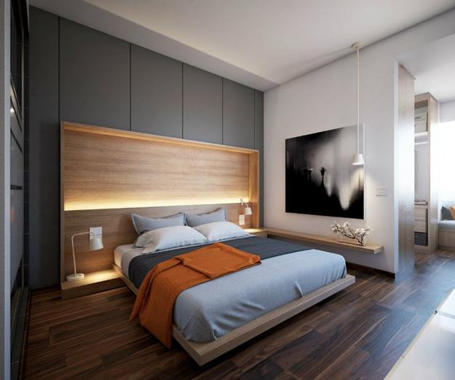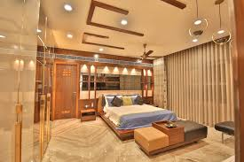

iv. Balconies – Creating the best atmosphere and nature view face comfort
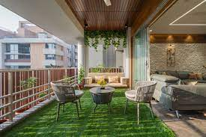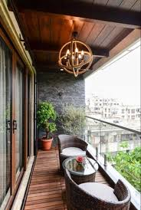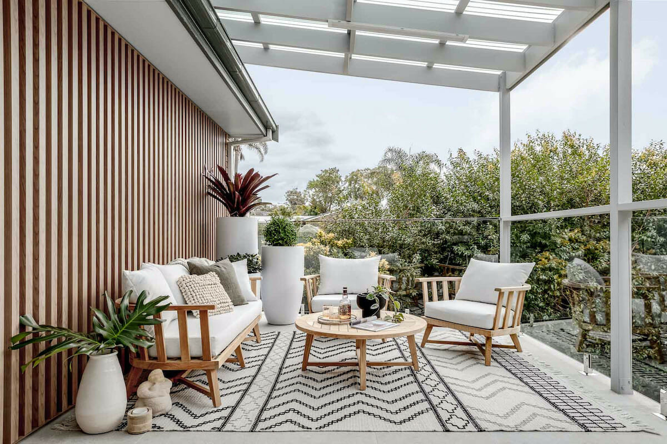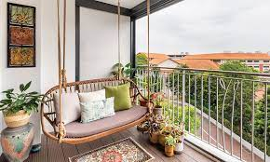

v. Wardrobes – Innovative internal design with attractive look
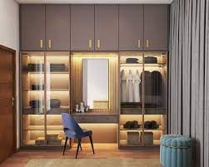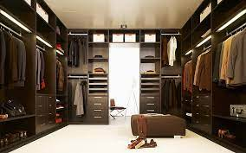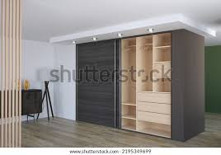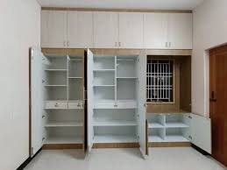

b. Corporate Design
Designing the creative design which gives satisfactory work atmosphere by considering space which also plans to include Reception area, Cafeteria, work area,
Entertainment area, Meeting area etc,,
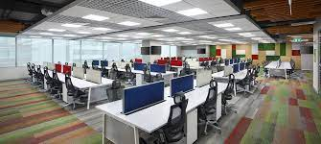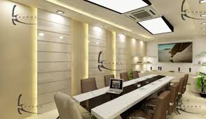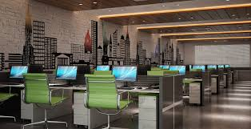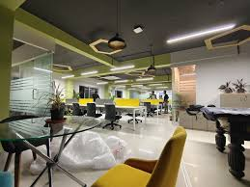

c. Institutional Design
Institutional design stands with most priority and responsible design. Our experienced designers with lot of prior experience can design best interior design.
They consider the most points like Local rules and regulations, Plan layout as functionality, Create a unique personality, bring the space to life with creativity, Ensure for adequate lighting and comfortable furniture’s
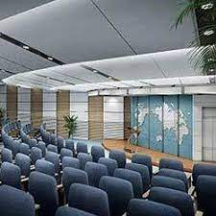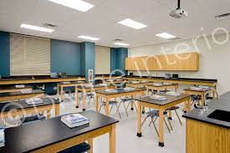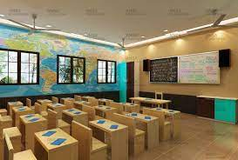

d. Hospitality
Dedicated professional designers has well known knowledge on the designing of restaurants, bars, clubs, casino's, cafés, pop-up or temporary restaurants, spas, lounges and more.
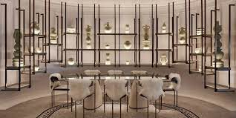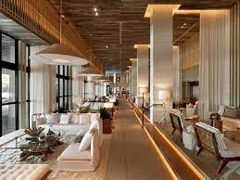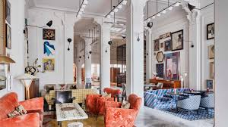
What we have done so far
Provided 10k Plus interior Design across the world
Where we serve
Across the world

